 

**Credentialling Workbook for Focused Echo in Life Support (FELS)**

**Contents**

1. Introduction Page 2
2. Checklist for submission Page 3
3. Instructional educational program Page 4
4. FELS protocol Page 5
5. Logbook requirements Page 6
6. Assessment forms Page 6, 7, 8
7. Certificate of completion Page 9
8. Maintenance Page 10

**Introduction**

The Focused Echo in Life Support (FELS) is an ultrasound examination designed for use in the cardiac arrest/peri arrest scenario. It is not a formal echo and it is recognised that in many patients, not all views will be of good quality. In addition, some echocardiographic windows may be inaccessible due to other factors such as contemporaneous procedures (e.g. CPR).

It aims to obtain the following information:

• Detection of pericardial effusion

• Assessment of left ventricular (LV) size and systolic function

• Assessment of right ventricular (RV) size and systolic function

• Gross estimate of fluid status (may require integration with other imaging e.g. lung/IVC)

The findings are then integrated with other clinical information, to consider causes of haemodynamic instability, for example hypovolemia, cardiogenic shock, tamponade, massive pulmonary embolism. Notably this examination is not comprehensive and does not evaluate valves, spectral doppler or diastolic function. It should not be used in lieu of comprehensive echocardiography, where clinically indicated.

The basic pathway to competency follows a structure of: theory and introductory phase, supervised practice, experience and exit assessment of competence, the details of which can be found in this booklet.

The credentialing process requires candidates to:

* Complete an appropriate instructional educational program
* Perform and record a requisite number of supervised and logged emergency department ultrasounds
  + A minimum of 25 accurate examinations must be performed
  + At least 50% of these examinations must be clinically indicated
  + At least five should be performed in in critical situations (ie shock/periarrest/cardiac arrest)
  + At least five examinations should be performed under the direct supervision of a sonologist credentialled in FELS, or a cardiac sonographer
  + There should be a minimum of two formative assessments completed
* Evidence of review of clinical images/loops from a further 25 cases should be provided. The cases that demonstrate the required pathology are available on the ACEM Ultrasound resources page.
* Of the minimum 50 FELS examinations (25 performed and 25 reviewed), there must be at least 2 cases each of pericardiac effusion, right heart failure/ massive pulmonary embolism, hypovolaemia or distributive shock and left ventricular failure.
* Pass a summative assessment
* Once credentialed, meet ongoing maintenance requirements
  + At least three hours of ultrasound training per year
  + Perform or supervise a minimum of 25 FELS examinations per two-year cycle and maintain a logbook to prove this for audit purpose

1. Personal Details



**Credentialling in Focused Echocardiography in Life Support (FELS)**

Unit Completion form

Family name:

Given names:

Email Address:

1. Educational Program

Introduction to ED POCUS course certificate

USS physics course certificate

FELS theory course certificate

FELS practical course component met, and certificate provided

1. Experience phase

I have used a logbook and the scans have been reviewed by a credentialled scanner/supervisor

My logbook contains: 25 accurate FELS scans, including scans used for assessments

50% of these scans are clinically indicated

5 of the scans were performed in critical care situations (ie. Shock/peri arrest/ cardiac arrest)

I have provided evidence of review of clinical images/loops from a further 25 cases

Of the minimum 50 scans, there are at least 2 cases each of pericardial effusion, right heart failure/ massive pulmonary embolism, hypovolaemia or distributive shock

The above requirements are clearly labelled and identifiable within my logbook.

1. Demonstration of Competence

I have completed 2 formative assessments and 1 summative assessment

Assessments are not completed on the same date

All assessments are signed by both my supervisor and me.

1. Maintenance Requirement

I acknowledge that to maintain these credentials I will undertake at least three hours of ultrasound training per year

I acknowledge that to maintain these credentials I must perform or supervise a minimum of 25 RCE examinations per two-year cycle and maintain a logbook to prove this for audit purposes

**Instructional Educational Program for RCE**

1. **Basic Ultrasound Knowledge:** A formal course should include education on the Physics of Ultrasound and Instrumentation. Online Ultrasound Courses that provide this basic knowledge include the Australasian College for Emergency Medicine (ACEM) Ultrasound Course modules. Anyone can access these modules by creating an ACEM login. The Introduction to POCUS and Physics course can be found at [Course: Ultrasound (acem.org.au)](https://elearning.acem.org.au/course/view.php?id=951) or <https://elearning.acem.org.au/course/view.php?id=951>
   1. **Physics:** Piezoelectric effect; Wave characteristics – cycle, frequency, period, wavelength, amplitude; Echogenicity; Image resolution; Attenuation; Doppler effect; Impedance; Artefacts; Bio-effects
   2. **Instrumentation**: Transducer types and selection; Transducer manipulation; Image labelling; Focu; Gain; Time gain compensation; Orientation; Scan planes; Image measurement; Infection control; Machine care and maintenance
2. **FELS Theory:** A formal course should instruct on normal anatomy, views obtained, possible findings, clinical algorithms and integration, limitations/pitfalls and reporting. ACEM also provides RCE learning modules [Course: Ultrasound (acem.org.au)](https://elearning.acem.org.au/course/view.php?id=951) or <https://elearning.acem.org.au/course/view.php?id=951>
   1. **Anatomy:** Cardiac chambers, cardiac valves, pericardium, great vessels, lung
   2. **Echocardiography practice**: Parasternal long axis, Parasternal short axis, Apical 4 and 5 chamber, subcostal long and short axis, inferior vena cava.
   3. **Findings:** Pericardial effusion and tamponade; left ventricular size and systolic function; right ventricular size and systolic function; estimation of volume status; limitations/pitfalls; reporting
   4. **Integration into clinical practice and algorithms:** Haemodynamically unstable patient; cardiac arrest; provision of a simple report form for use in the peri-arrest/arrest setting which states the limited nature of the exam and what clinical questions have and have not been answered. This is to avoid confusion with the information that would be obtained by a comprehensive echocardiogram. =
3. **FELS Practical ultrasound sessions.** It is essential that practical ultrasound sessions include:
   1. Demonstration of correct application protocol for emergency indication.
   2. Minimum time – four hours
   3. Maximum student:instructor ratio – 5:1
   4. Live ultrasound models for scanning sessions, preferably including both normal subjects and patients with demonstrable pathology. Patients or professional-grade simulators are preferable for abnormal anatomy. However, they may not always be readily available. In such cases, ultrasound cineloops showing the same pathology may be substituted.

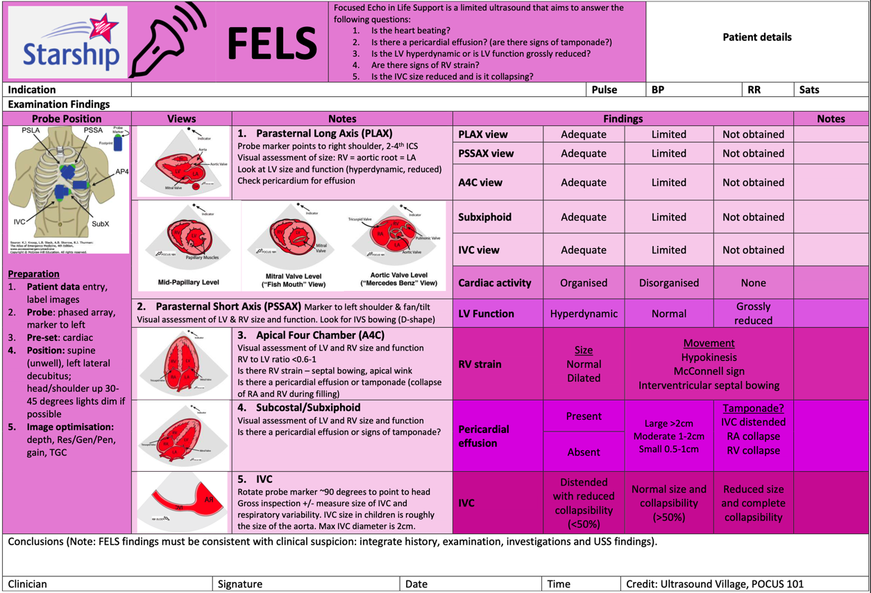

**Logbook requirements**

Patients must be informed that the ultrasound examination is being performed for credentialing purposes and verbal or written consent obtained.

Ultrasound examinations must be documented in an appropriately secure logbook. The entry should include:

* Clinical details
* Date and type of ultrasound examination performed
* Findings
* Candidate’s interpretation of those findings
* The findings and interpretation should subsequently be compared to other clinical data and a notation made as to whether the scan findings were accurate.
* Where the scan was not supervised there should be confirmatory evidence of the accuracy of the examination (via additional studies or clear clinical evidence).
* All logbook scans should be either directly proctored, or the images reviewed at a later date by one of the trainee’s supervisors.

We encourage you to perform as many of your logbook scans as possible with a credentialed clinician in order to gain feedback.

A logbook template can be found on the CED Credentialling page under “Credentialling Resources”

**Assessments**

For each modality, at least two directly supervised formative assessments must be completed prior to a final summative assessment. Assessments forms can be found on the next page or on the CED Ultrasound website.

The final summative assessments and credentialing process must be overseen by a clinician who is themselves credentialed in that modality. They will observe the candidate performing the ultrasound examination and will not give any feedback during this examination. This may be undertaken simultaneously as a Direct Observations of Procedural Skill (DOPS) assessment for FACEM Trainees.

Once the examination requirements are satisfied, the emergency medicine practitioner will be credentialed for the appropriate ultrasound module. The emergency medicine sonologist may then document the results of his/her ultrasound scans in the medical record and incorporate the results into clinical decisions. ACEM has a formal link with the Australasian Society for Ultrasound Medicine. ACEM accepts successful completion of the Certificate in Clinician Performed Ultrasound (CCPU) as appropriate demonstration of competence.

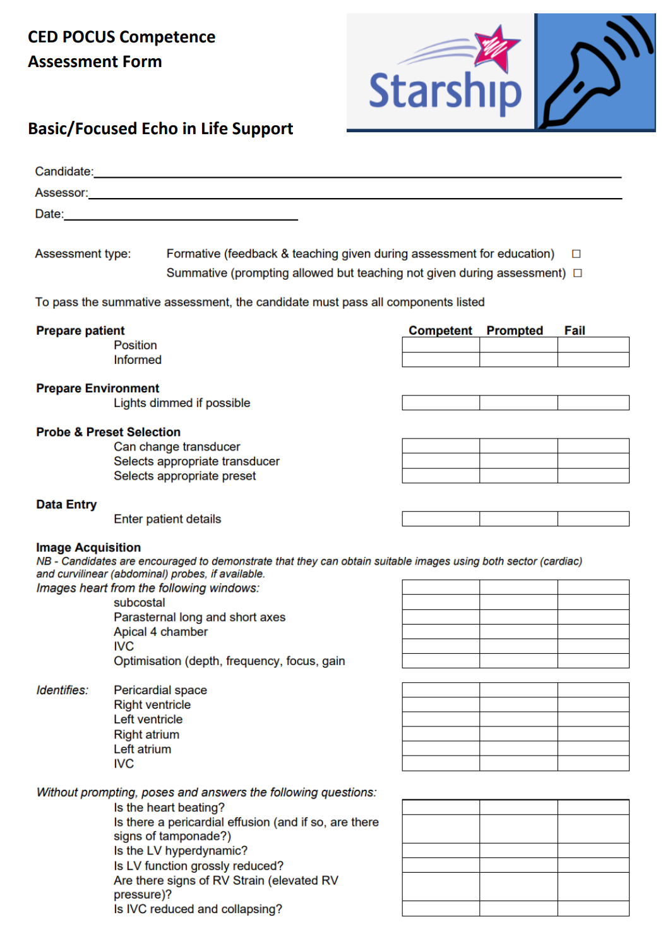



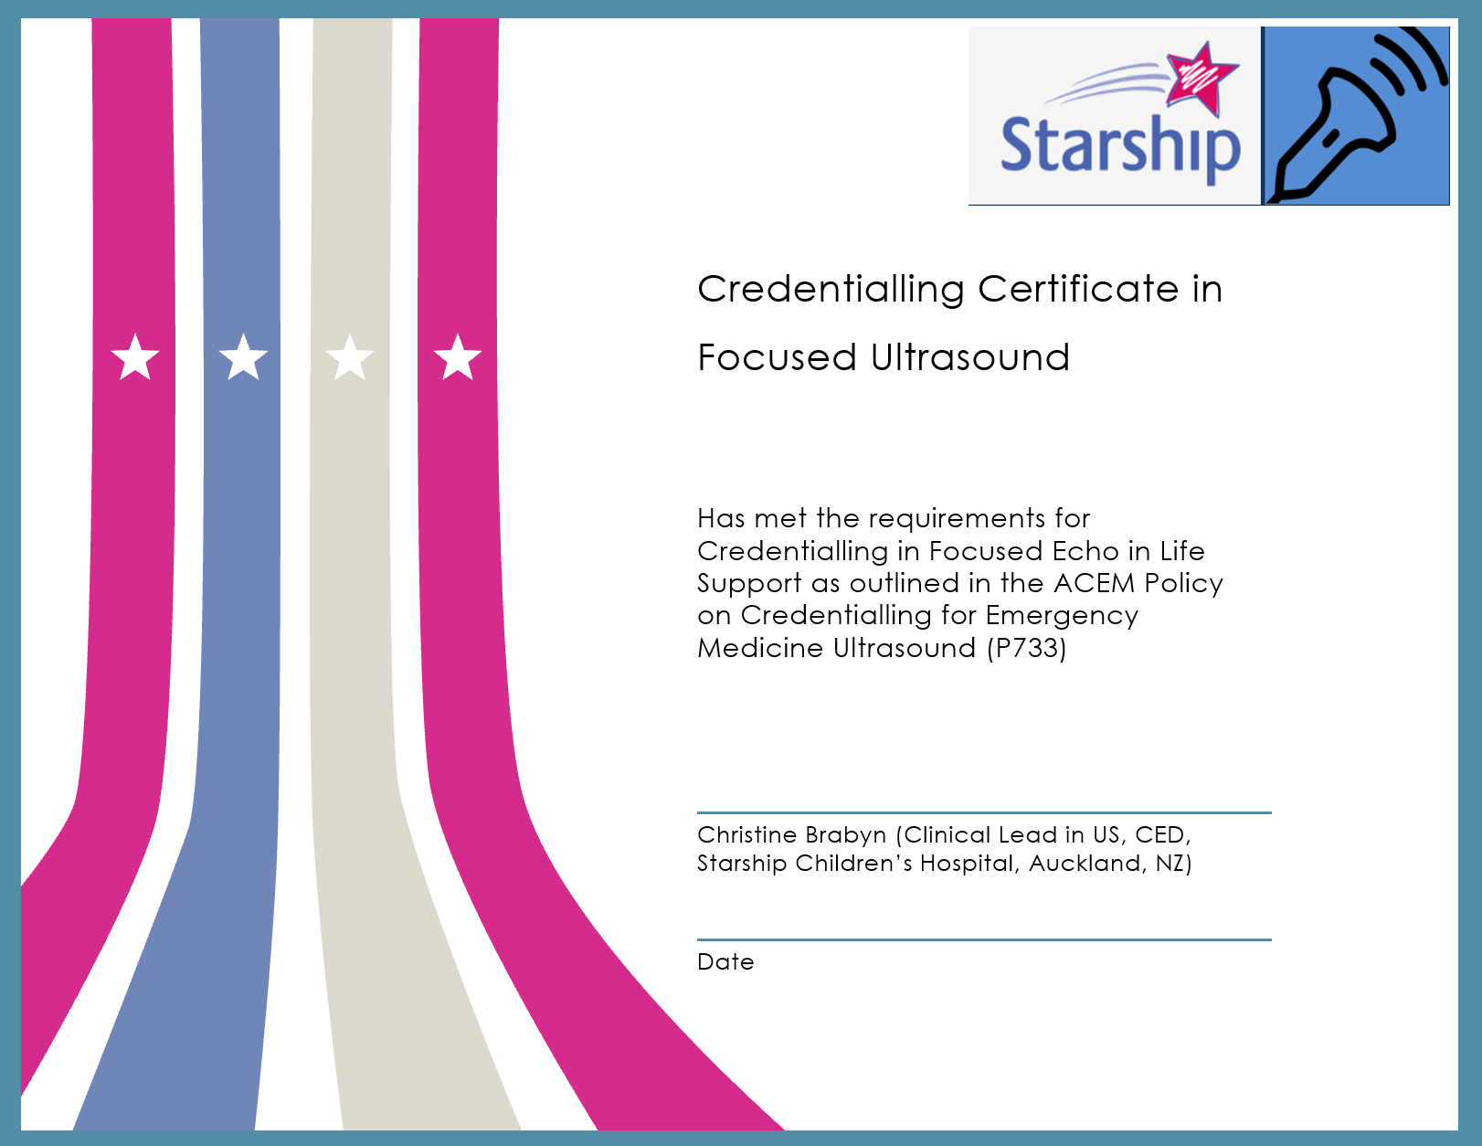

**Credentialling Maintenance**

To maintain his/her credentials, the emergency medicine sonologist should undertake at least three hours of ultrasound training per year. This may include:

* 1:1 training with a qualified Sonographer Educator in ED (SEED);
* attending or presenting at an ultrasound webinar/workshop or conference;
* teaching on an accredited course;
* participation in ultrasound quality assurance and retrospective image review; and
* reading Ultrasound journals or textbooks.

For the RCE module, the emergency medicine sonologist must perform or supervise a minimum of 25 scans per two-year cycle. It is recommended these are logged in a logbook for audit purposes. An example logbook could contain the following columns:

* Date
* Case for 14 years and under?
* Supervised scan? (Did you supervise this scan, rather than personally perform?)
* Trainee’s name (if supervised scan)
* Clinical Indication (indicate the symptoms or condition that substantiates the necessity for further investigation by an ultrasound scan)
* Positive?
* Interpretation and Clinical Findings
* Comparison with further imaging or clinical outcome