 

**Credentialling Workbook for Basic Lung Ultrasound**

**Contents**

1. Introduction Page 2
2. Checklist for submission Page 3
3. Instructional educational program Page 4
4. Basic Lung protocol Page 5
5. Logbook requirements Page 6
6. Assessment forms Page 6, 7, 8
7. Certificate of completion Page 9
8. Maintenance Page 10

**Introduction**

Basic lung ultrasound examination can be used to detect the absence of lung sliding, interstitial fluid syndromes, pleural effusion, and consolidation. The examination involves scanning the lungs in a minimum of four zones.

The basic pathway to competency follows a structure of: theory and introductory phase, supervised practice, experience and exit assessment of competence, the details of which can be found in this booklet.

The credentialing process requires candidates to:

* Complete an appropriate instructional educational program
* Perform and record a requisite number of supervised and logged emergency department ultrasounds
  + A minimum of 25 accurate examinations must be performed
  + At least 50% of these examinations must be clinically indicated
  + At least five should be demonstrate significant pathology e.g. pneumothorax, effusion, pneumonia, interstitial syndrome
  + There should be a minimum of two formative assessments completed
* Pass a summative assessment
* Once credentialed, meet ongoing maintenance requirements
  + At least three hours of ultrasound training per year
  + Perform or supervise a minimum of 25 Lung Ultrasound examinations per two-year cycle and maintain a logbook to prove this for audit purpose



**Credentialling in Basic Lung Ultrasound**

Unit Completion form

1. Personal Details

Family name:

Given names:

Email Address:

1. Educational Program

Introduction to ED POCUS course certificate

USS physics course certificate

Lung Ultrasound theory course certificate

Lung Ultrasound practical course component met, and certificate provided

1. Experience phase

I have used a logbook and the scans have been reviewed by a credentialled scanner/supervisor

My logbook contains: 25 accurate Lung ultrasound scans, including scans used for assessments

50% of these scans are clinically indicated

There are at least 5 positive scans for significant pathology e.g. pneumothorax, effusion, pneumonia, interstitial syndrome

The above requirements are clearly labelled and identifiable within my logbook.

1. Demonstration of Competence

I have completed 2 formative assessments and 1 summative assessment

Assessments are not completed on the same date

All assessments are signed by both my supervisor and me.

1. Maintenance Requirement

I acknowledge that to maintain these credentials I will undertake at least three hours of ultrasound training per year

I acknowledge that to maintain these credentials I must perform or supervise a minimum of 25 Lung US examinations per two-year cycle and maintain a logbook to prove this for audit purposes

**Instructional Educational Program for Basic Lung Ultrasound**

1. **Basic Ultrasound Knowledge:** A formal course should include education on the Physics of Ultrasound and Instrumentation. Online Ultrasound Courses that provide this basic knowledge include the Australasian College for Emergency Medicine (ACEM) Ultrasound Course modules. Anyone can access these modules by creating an ACEM login. The Introduction to POCUS and Physics course can be found at [Course: Ultrasound (acem.org.au)](https://elearning.acem.org.au/course/view.php?id=951) or <https://elearning.acem.org.au/course/view.php?id=951>
   1. **Physics:** Piezoelectric effect; Wave characteristics – cycle, frequency, period, wavelength, amplitude; Echogenicity; Image resolution; Attenuation; Doppler effect; Impedance; Artefacts; Bio-effects
   2. **Instrumentation**: Transducer types and selection; Transducer manipulation; Image labelling; Focus; Gain; Time gain compensation; Orientation; Scan planes; Image measurement; Infection control; Machine care and maintenance
2. **Lung Ultrasound Theory:** A formal course should instruct on normal anatomy, views obtained, possible findings, clinical algorithms and integration, limitations/pitfalls and reporting. ACEM also provides a Thoracic/Lung learning module [Course: Ultrasound (acem.org.au)](https://elearning.acem.org.au/course/view.php?id=951) or <https://elearning.acem.org.au/course/view.php?id=951>
   1. **Anatomy:** Lung surface markings of upper, middle and lower lobes; Lung zones 1-4 or 1-6; diaphragm; ribs; pleural surface; spine; heart; liver; spleen; thymus
   2. **Practical:** Optimise machine preset/settings to scan lungs; Scan lung zones 1-4 (or 1-6); identify diaphragms and lung curtain; identify ribs, intercostal space, pleural line; identify lung sliding; identify lung pulse; identify comet tail and other artefacts
   3. **Findings:** Normal lung; absent lung sliding (and how to differentiate causes); Focal B lines; Diffuse B lines; Consolidation; Pleural effusion
   4. **Integration – clinical cases:** Pneumonia; Interstitial syndrome; Cardiogenic pulmonary oedema; Lung fibrosis; Pneumothorax; Pleural effusion; Bronchiolitis/viral pneumonitis; Integration of lung ultrasound into resuscitation (initial assessment and in monitoring response e.g early evidence of fluid overload)
   5. **Pitfall cases**
3. **Lung Practical ultrasound sessions.** It is essential that practical ultrasound sessions include:
   1. Demonstration of correct application protocol for emergency indication.
   2. Minimum time – two hours
   3. Maximum student:instructor ratio – 5:1
   4. Live ultrasound models for scanning sessions, preferably including both normal subjects and patients with demonstrable pathology. Patients or professional-grade simulators are preferable for abnormal anatomy. However, they may not always be readily available. In such cases, ultrasound cineloops showing the same pathology may be substituted.

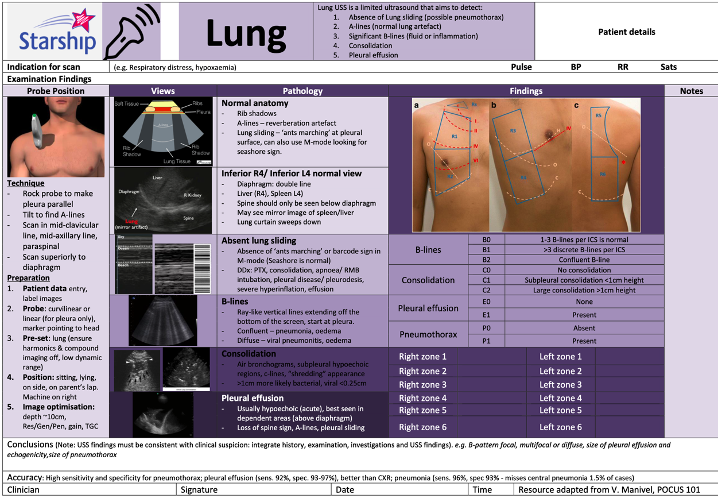

**Logbook requirements**

Patients must be informed that the ultrasound examination is being performed for credentialing purposes and verbal or written consent obtained.

Ultrasound examinations must be documented in an appropriately secure logbook. The entry should include:

* Clinical details
* Date and type of ultrasound examination performed
* Findings
* Candidate’s interpretation of those findings
* The findings and interpretation should subsequently be compared to other clinical data and a notation made as to whether the scan findings were accurate.
* Where the scan was not supervised there should be confirmatory evidence of the accuracy of the examination (via additional studies or clear clinical evidence).
* All logbook scans should be either directly proctored, or the images reviewed at a later date by one of the trainee’s supervisors.

We encourage you to perform as many of your logbook scans as possible with a credentialed clinician in order to gain feedback.

A logbook template can be found on the CED Credentialling page under “Credentialling Resources”

**Assessments**

For each modality, at least two directly supervised formative assessments must be completed prior to a final summative assessment. Assessments forms can be found on the next page or on the CED Ultrasound website.

The final summative assessments and credentialing process must be overseen by a clinician who is themselves credentialed in that modality. They will observe the candidate performing the ultrasound examination and will not give any feedback during this examination. This may be undertaken simultaneously as a Direct Observations of Procedural Skill (DOPS) assessment for FACEM Trainees.

Once the examination requirements are satisfied, the emergency medicine practitioner will be credentialed for the appropriate ultrasound module. The emergency medicine sonologist may then document the results of his/her ultrasound scans in the medical record and incorporate the results into clinical decisions. ACEM has a formal link with the Australasian Society for Ultrasound Medicine. ACEM accepts successful completion of the Certificate in Clinician Performed Ultrasound (CCPU) as appropriate demonstration of competence.

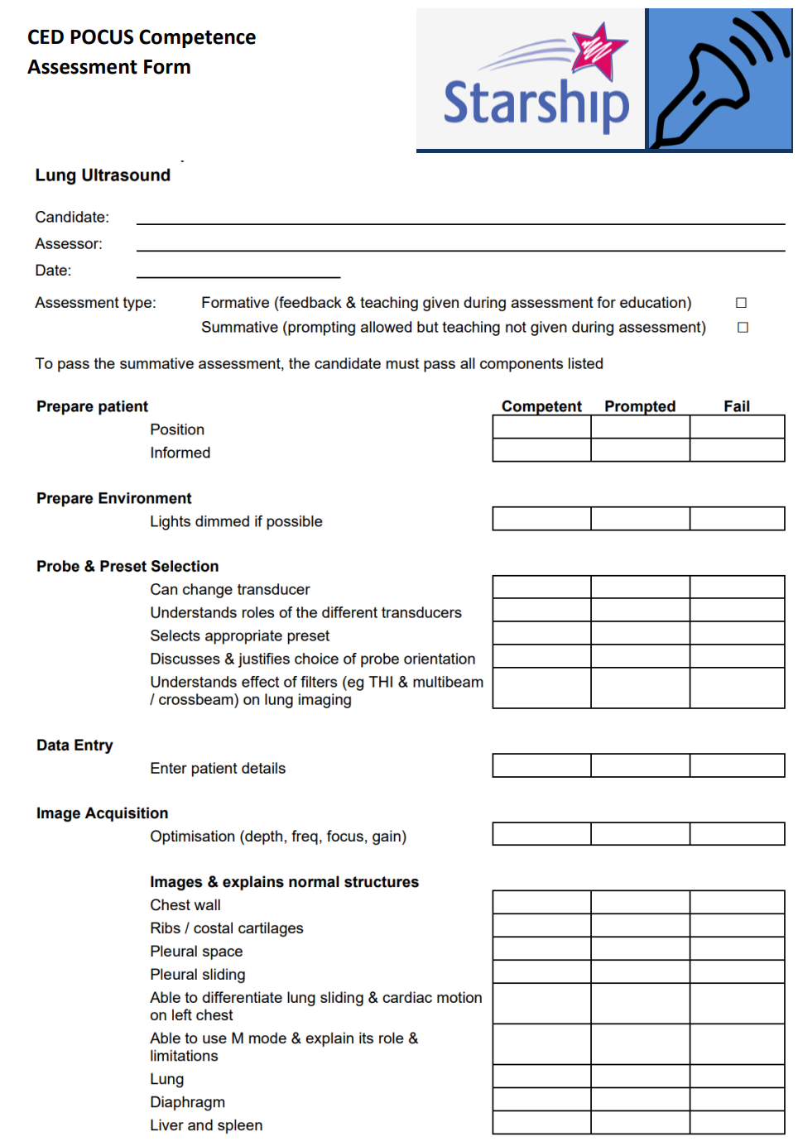

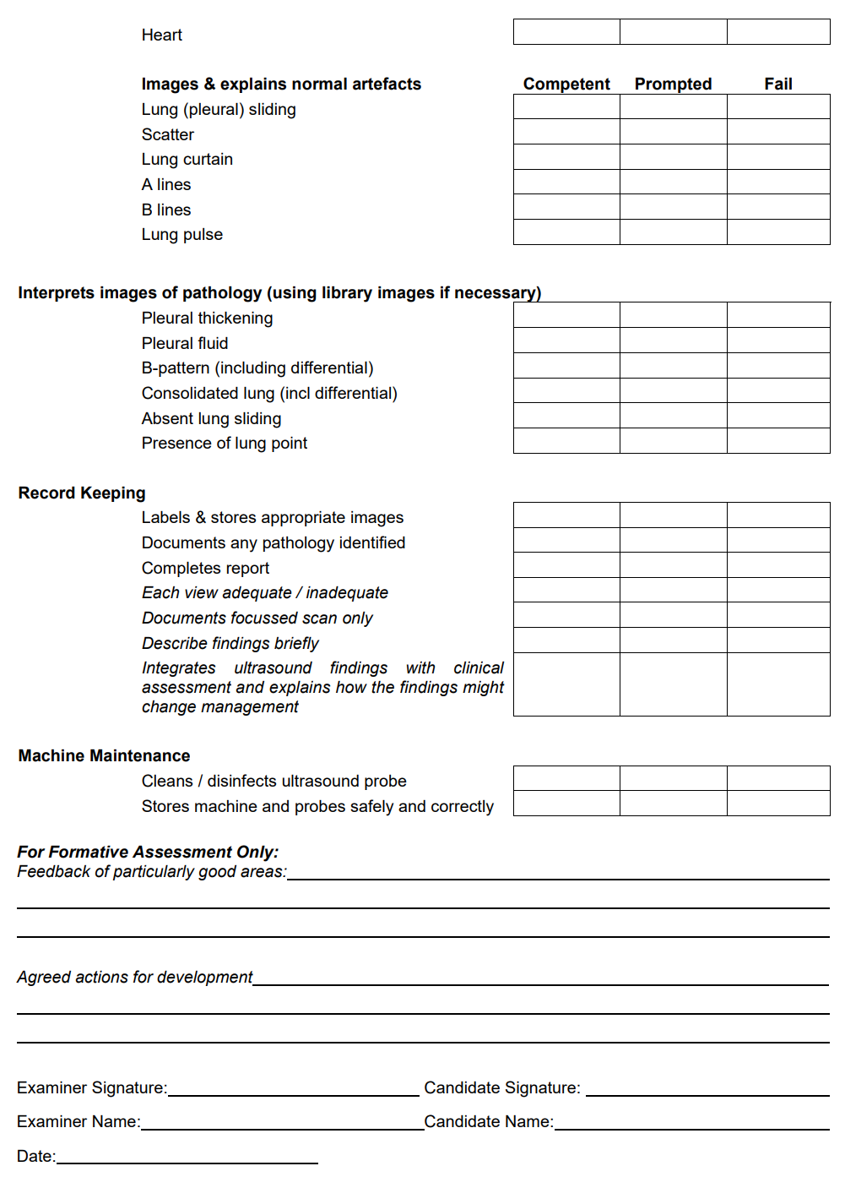

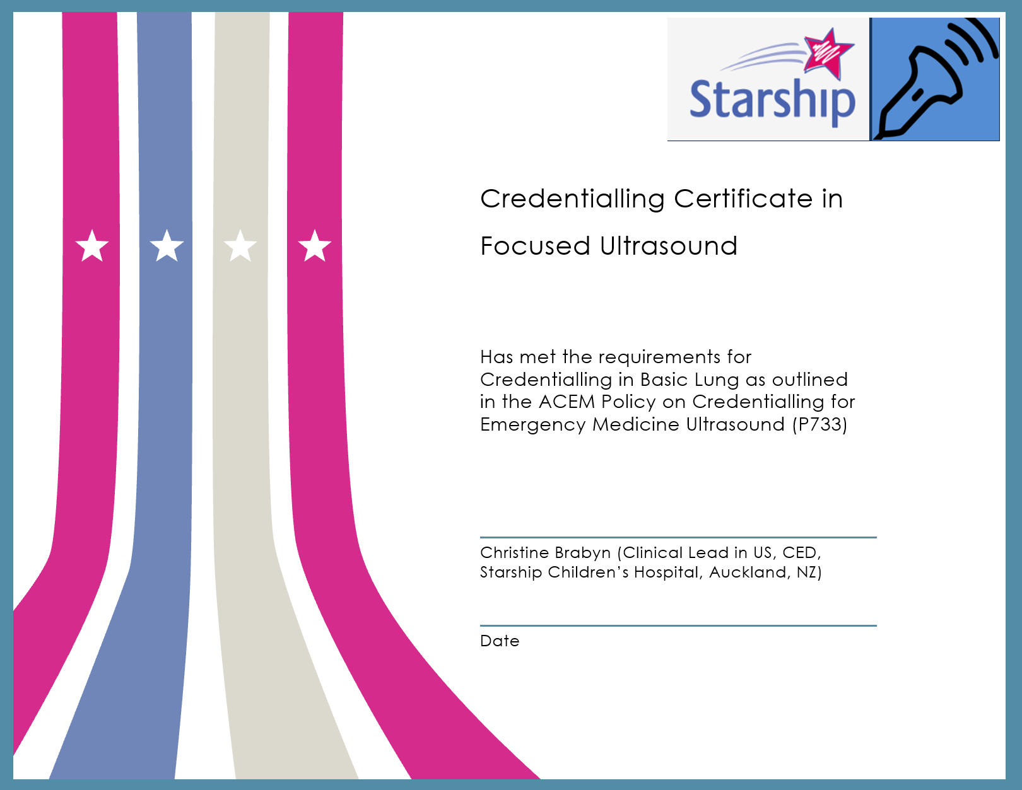

**Credentialling Maintenance**

To maintain his/her credentials, the emergency medicine sonologist should undertake at least three hours of ultrasound training per year. This may include:

* 1:1 training with a qualified Sonographer Educator in ED (SEED);
* attending or presenting at an ultrasound webinar/workshop or conference;
* teaching on an accredited course;
* participation in ultrasound quality assurance and retrospective image review; and
* reading Ultrasound journals or textbooks.

For the Lung Ultrasound module, the emergency medicine sonologist must perform or supervise a minimum of 25 scans per two-year cycle. It is recommended these are logged in a logbook for audit purposes. An example logbook could contain the following columns:

* Date
* Case for 14 years and under?
* Supervised scan? (Did you supervise this scan, rather than personally perform?)
* Trainee’s name (if supervised scan)
* Clinical Indication (indicate the symptoms or condition that substantiates the necessity for further investigation by an ultrasound scan)
* Positive?
* Interpretation and Clinical Findings
* Comparison with further imaging or clinical outcome